- A.
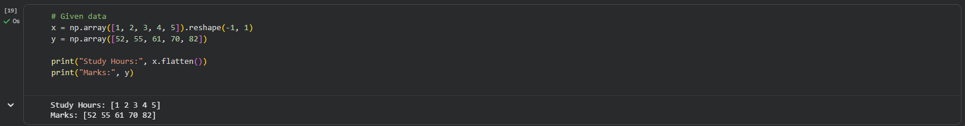
B.
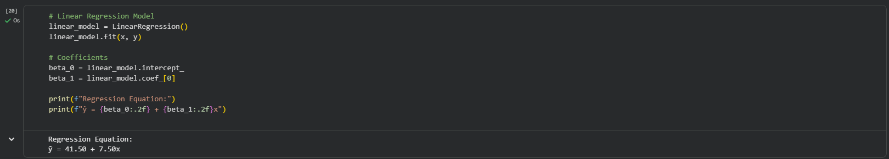
2) A.
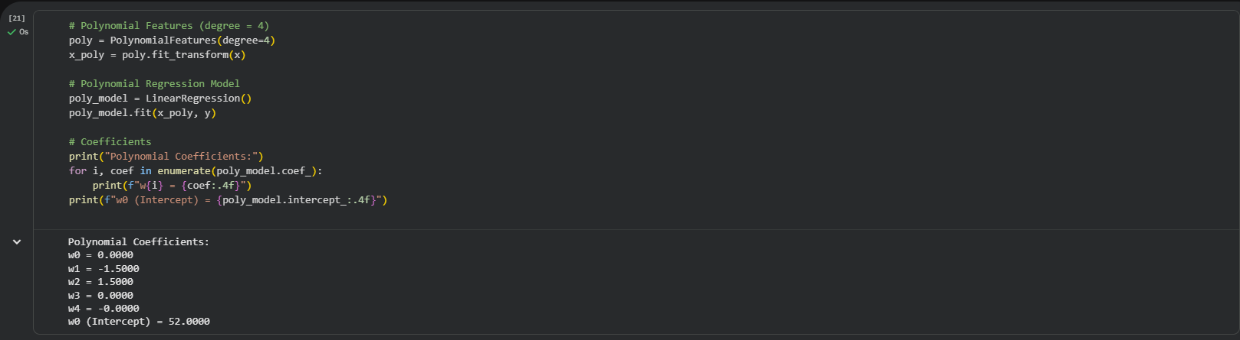
b.
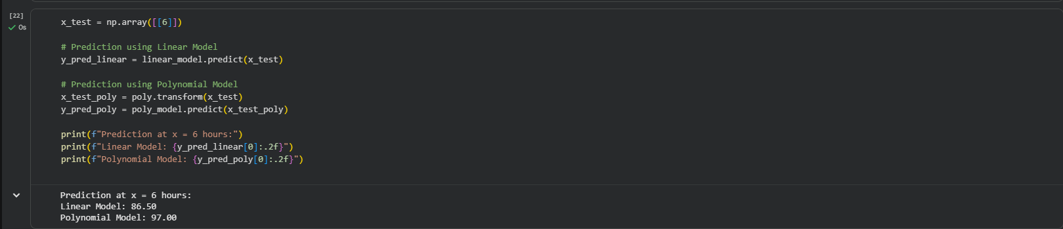
3) A.
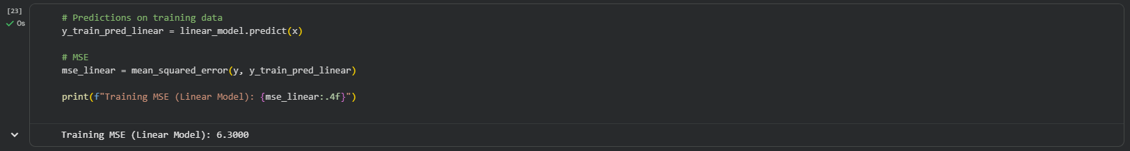
b.
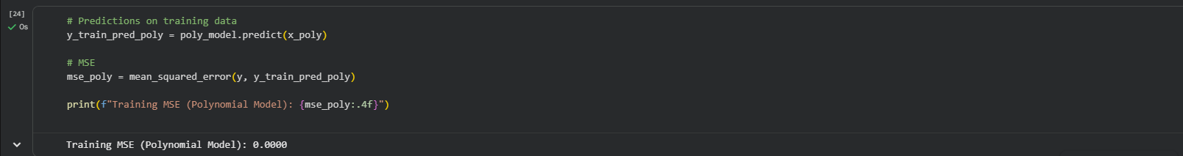
4)
Bias–Variance Analysis
• Higher Bias:
Model A (Linear Regression)
Reason: It is too simple to capture the non-linear relationship.
• Higher Variance:
Model B (Polynomial Regression – Degree 4)
Reason: It closely fits the training data and may overfit, making it sensitive to data changes.

